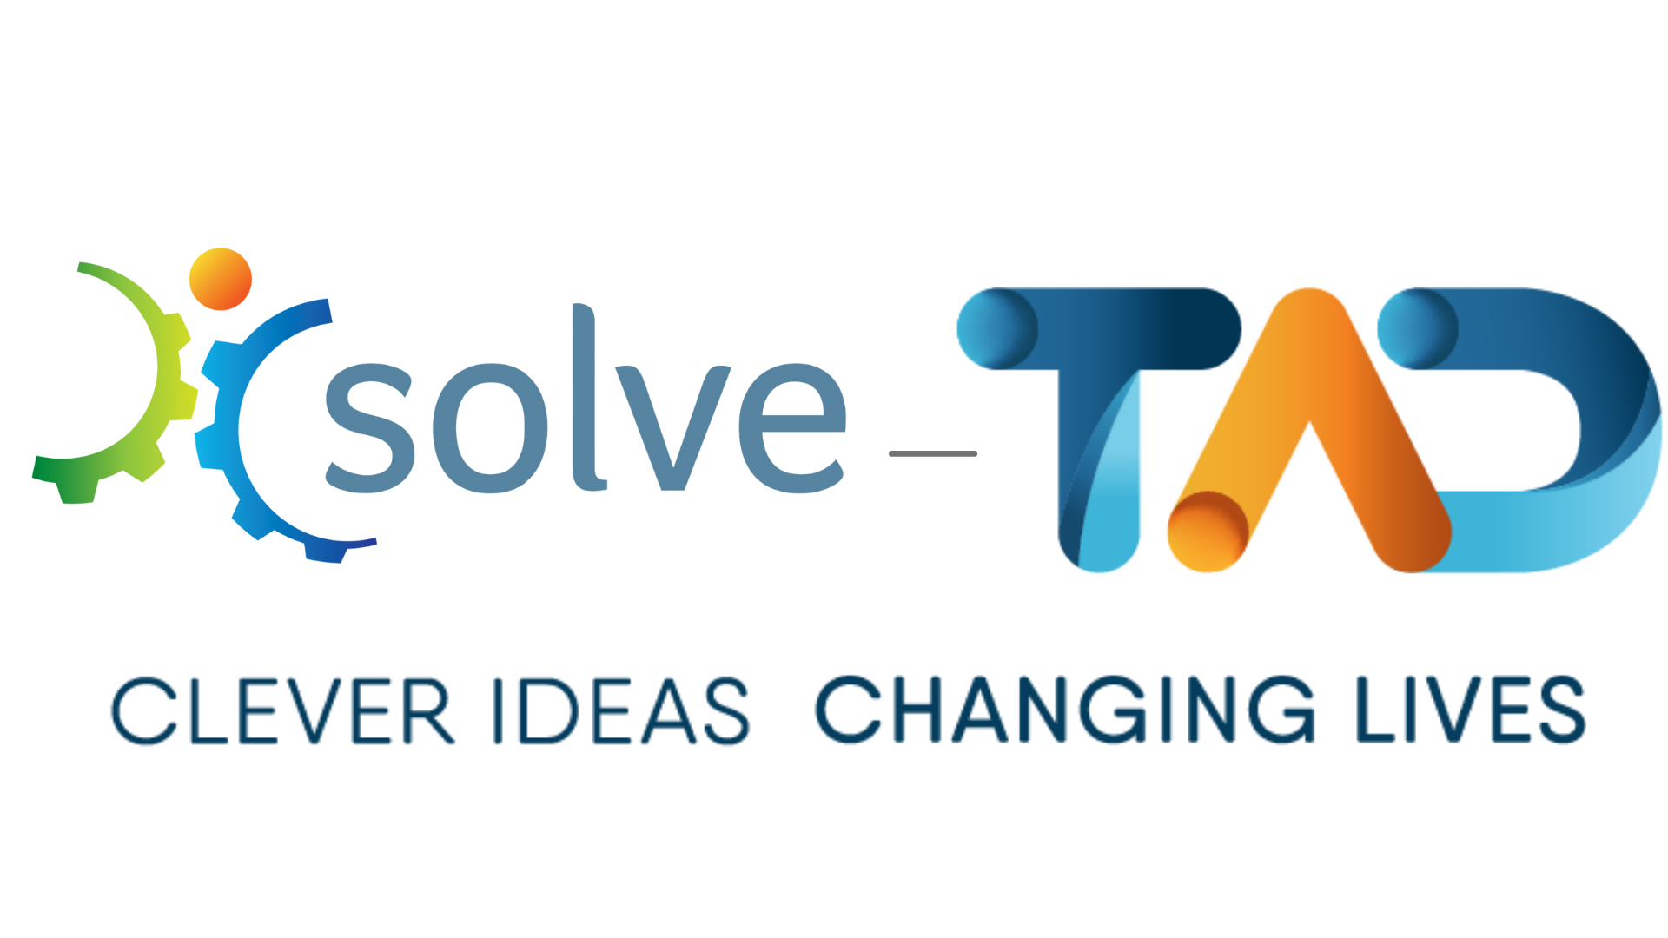

Ern and Les Rothschild Volunteering Award
1. Background
Ern Rothschild was a Solve Disability Solutions (then known as TADVIC) technical member from 1990 until he passed away in 2007. He and his wife Les were great supporters of the work of Solve-TAD. They both attended VIC Annual General Meetings and functions and took every opportunity to promote the work of Solve-TAD. Ern worked on over 110 projects in his 17 years with Solve-TAD, with products made ranging from items to make personal care easier, to equipment to enable greater participation in vocational and recreational activities. In 2012 Ern’s wife, Les, left a large financial bequest to Solve-TAD in her Will. In honour of both the practical and financial commitment shown by the Rothschild’s to Solve-TAD we dedicate this award to their honour.
2. Eligibility
- The award is open to all volunteers, and can be for an individual or team.
- The nominee/s is not required to be a Solve member; they can just have volunteered with Solve-TAD.
- The recipient/s can be nominated by another volunteer, client, supporter or staff member.
- Past individual winners are not eligible for future awards. However they may be renominated as part of a volunteer team.
3. Criteria
The Award recipient would not have to meet the entire set of criteria, however in order to assess each nomination fairly there needs to be a way of comparing the nominees with each other to determine the most deserving volunteer. For the initial awards the following criteria will be applied:
- How has the person supported other volunteers?
- How has the person supported or shown commitment to the organisation?
- What effect has the volunteer had on the community and/or client?
- How has the volunteer displayed qualities such as humility, flexibility and reliability?
- Approximately what amount of time would they commit to the organisation (per week)?
- The effort required to volunteer (e.g. obstacles they face such as health, caring responsibilities, working etc.)
- How have they demonstrated a commitment to people with a disability?
- What work/project/activity has they done that was outstanding and why? - E.g. highly innovative, large amount of time invested, outcome for client etc.
4. Nomination process
- Nominations will be open from 1 May to 31 August each year.
- Nominator to complete a Nomination Form.
- Nomination Form to be submitted to the Volunteer Coordinator for collation.
- Collated nominations will be forwarded to the CEO in the first week of September.
- Nominations to be assessed and reviewed by a Sub Committee that includes the CEO, Board Chairman and one other Board member.
- The recipient is to be announced at the AGM each year and will be presented with a certificate, a small trophy and a gift voucher (to the value of $200).

Other information
The Ern and Les Rothschild Volunteering Award will be launched at the May Branch Day in 2015. Following this, each year at the May Branch Day a reminder about the award would be given. Notices about the Award would also be sent out to each Branch and an article placed in the Volunteer Newsletter and Website.

Soft copy Nomination forms are available from the Solve Website and hard copies will be sent out to branches and kept at central office.

Ern and Les Rothschild Volunteering Award 2022
NOMINATION FORM
This award is dedicated to the memory of past volunteer Ern Rothschild and his wife Les who supported the organisation from 1990 to 2007 and generously remembered Solve-TAD in their Will.
THE PERSON/TEAM YOU ARE NOMINATING
Nominee’s Name/s: _______________________________________________________
Branch: _______________________________________________________
CRITERIA
You are required to write the reasons you feel this person or team deserves to be recognised for their volunteer work with Solve-TAD. Please use the following criteria as guidelines, complete all or as many of the criteria that you believe are applicable to this person. (Can be typed in or hand written)

1. How has the person supported other volunteers?

2. How has the person supported or shown commitment to the organisation?

3. What effect has the volunteer had on the community and/or client?

4. How has the volunteer displayed qualities such as humility, flexibility and reliability?

5. Approximately what amount of time would they commit to Solve-TAD (per week)

6. The effort required to volunteer (e.g. obstacles they face such as health, caring responsibilities, working etc.)

7. What work/project/activity did they undertake that you believe was outstanding and why? E.g. highly innovative, immense amount of time invested, outcome for client etc.

8. Any additional supporting information.

THE PERSON MAKING THE NOMINATION
(Please provide your details)

Name: _______________________________________________________
Contact number: ______ _________________________________________________
Address: ________________________________________________________
Suburb: __________________________Postcode: _____________________
Email: ________________________________________________________
Relationship to nominee/s: _______________________________________________________
________________________________________________________
________________________________________________________
LODGING THE NOMINATION FORM
The completed nomination form is to be returned to:
volunteer@solve.org.au

Closing Date: 30th September 2022

